**Lavanya Bommidi**

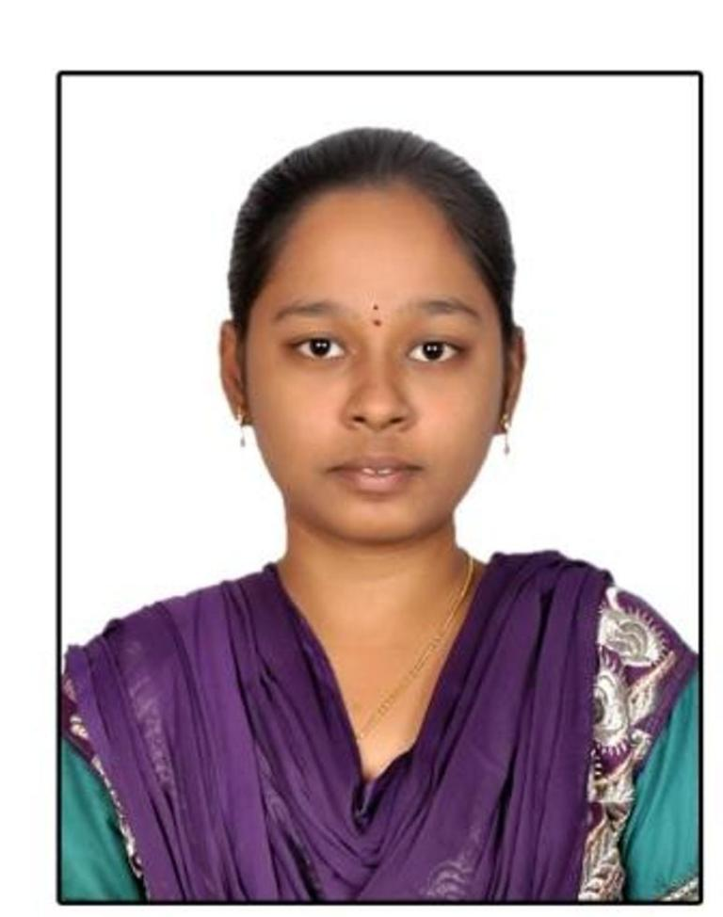

|  |  |
| --- | --- |
| **Title:** | **Senior Software Engineer** |
| **Location:** | **Siruseri, Chennai, India** |
| **Languages:** | Telugu (native), English (fluent), Hindi (conversational) |

# Experience Summary

Lavanya is a Senior Software Engineer with 2 years 8 months of professional experience in software company. She is currently working as Senior Developer in Elite Development project. She has excellent capability to explore, learn and understand newer business domains and technology. She is certified in Automation Engineering Foundation and UiPath by Capgemini. She has been trained in JAVA domain for three months in Bangalore. She has successfully completed her L1 exam in December 2016.

**KEY SKILLS:**

* **Functional:** Strategic/Tactical Planning, Excellent Communication and Interpretation skills.
* **Technical:** Java/J2EE, Oracle PL/SQL, JSP, HTML, CSS, JDBC, JavaScript, jQuery, Angular JS, PHP, Spring Boot.

# Experience

Professional Experience

**Project: 01**

|  |  |
| --- | --- |
| Title | Elite Development Project - Full Stack Development |
| Technology | Java, AngularJs, PHP, Spring, HTML, CSS. |
| Client | General Electric, US |
| Description | Engine Lifecycle Information Tracking for Evaluation is a web based tool with IIDS design. It is a Role & Permission based access application. It has different modules like Fleet Intelligence, Analysis reports, Quality checks reports, Tracking reports, Admin. |
| Role | Senior Developer |
| Duration | January 2018 to till date. |
| Responsibilities | * Developed PDF Parsing tool which will read the pdf, store the pdf in Amazon S3 and then access to parse the images and the captions using co-ordinate mapping, which maps the coordinates of the key words and images. And then separating the images and uploading the into respective components based on the description formed and displaying them to the user. This process reduces the user time to manual take images from pdf and uploading in the respective components. * Involved in development of Depot Report Module in Analysis Repots. * Involved in Generating PDF reports based on the data that user entered in depot report module. * Involved in production support activity. * Involved in testing the application thoroughly. |

**Project: 02**

|  |  |
| --- | --- |
| Title | Renewable Energy - Application Maintenance |
| Technology | Java, Predix, Oracle PLSQL, JSF, JBOSS, Hibernate, Analytics, Support Central Workflows, CVS. |
| Client | General Electric, US |
| Description | Our Renewables Customer initiative of one stop shop for renewables external customers is REconnect. This application is custom built JBOSS portal which enables customers to shop the wind farm parts, turbines and avail services of assessments on the wind farms and lot more. This portal integrates 10 different applications into a single platform. The portal provides core business capabilities of buying the wind parts and services to external customers that are critical to the customer renewables business for generating revenue. |
| Role | Analyst. |
| Duration | May 2017 to December 2017 |
| Responsibilities | * Responsible for coordinating with the team and the delivering the results. * Responsible for maintenance of the user access workflow developed on the support central workflows. * Responsible for testing various reports, interfaces and extensions during testing cycles. * Involved in the Deployment and Documentation phases. * Responsible for maintenance of service now tickets. * Responsible for AKANA URL Configuration. * Assisted the team in various SDLC phases as required to complete the task with good quality. |

# Training, Certifications & Affiliations

* Certified in Foundation Level Automation drive academy (Capgemini internal).
* Certified in UiPath.
* Attended for Docker, Node JS, Bootstrap trainings.
* J2EE certified from Capgemini.

# Higher Education

* Raghu Engineering College, JNTUK, Visakhapatanam – Bachelor of Technology in Electronics and Communication.